30 March 2026 - FIRST DRAFT OF PAGE BY PAGE EXPLANATION:

General:

Going to sell this platform as a subscription and market it to Aadvocates and Attorneys.

Advocates use Zoho or Saige and attorneys need tracking for trust and business.

So must provide for both.

PRACTICE

Dashboard

Law Practice Dashboard

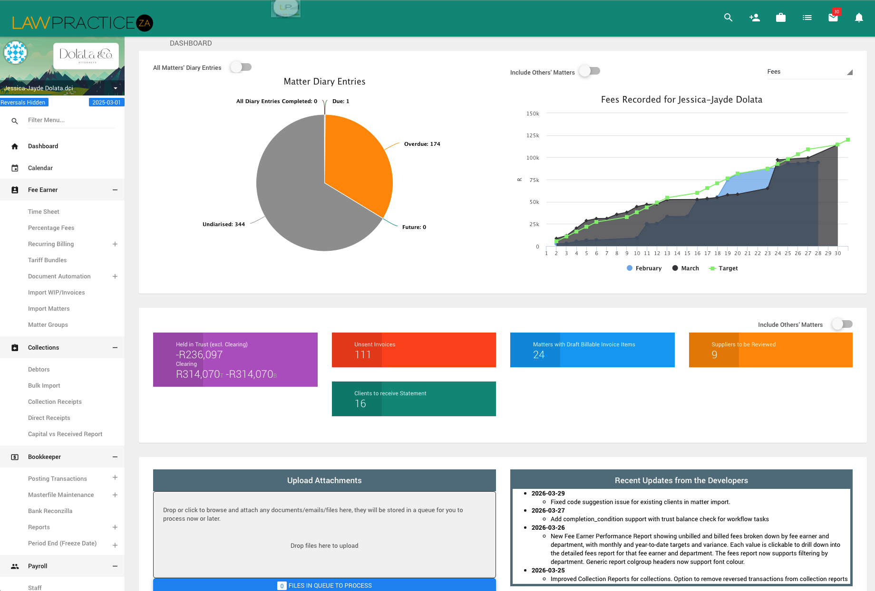

Purpose:

Place to see and do everything at a quick glance.

Main features:
- Search function at the top
  - Can search by matter, client, ref nr or name
- Graph of fees
  - Past month
  - Current month
  - Target
  - (Should be able to toggle the view to also see last 6 months, 1 year, 2 years, 3 years, 5 years etc)
- Work In progress (Draft billable items)
  - Can have an overview but needs a page of its own
  - Unbilled time, categorized by matters
- Unsent invoices
- Firm Overview
  - R____ Outstanding Debtors
  - R______ Unsent invoices
  - Deadlines this week
  - ?
- SIDE PANEL
  - Calendar to add entry
  - Today Diary
  - Coming Up – chronological order of all up and coming events not just this week.
- TOP BAR:
  - ADD: Add quick action to add a new client to contact
    - For example if we get a call and we need to send them a new consult email we click a button and it allows us to insert their details which will trigger a flow to send them an email for a consultation.
    - Their details must then be saved in a new tab in Clients > new client leads.

To Add:
- Chatbot at the bottom so you can just ask it anything at any point re this data

Matters

List of all the matters that you can then select and go into each matter page

Client Surname, FN | Matter Subject | Summary | To Do + Allocation* | Status | Comment/ Deadline

Must be able to sort by the above columns.

*To Do + Allocation should be a list of To do items and then can allocate to specific people and it will appear in their calendar with a due date.

New Matters

- Matter type and department needs clarity

Inside Each matter:

This is what law practice looks like:

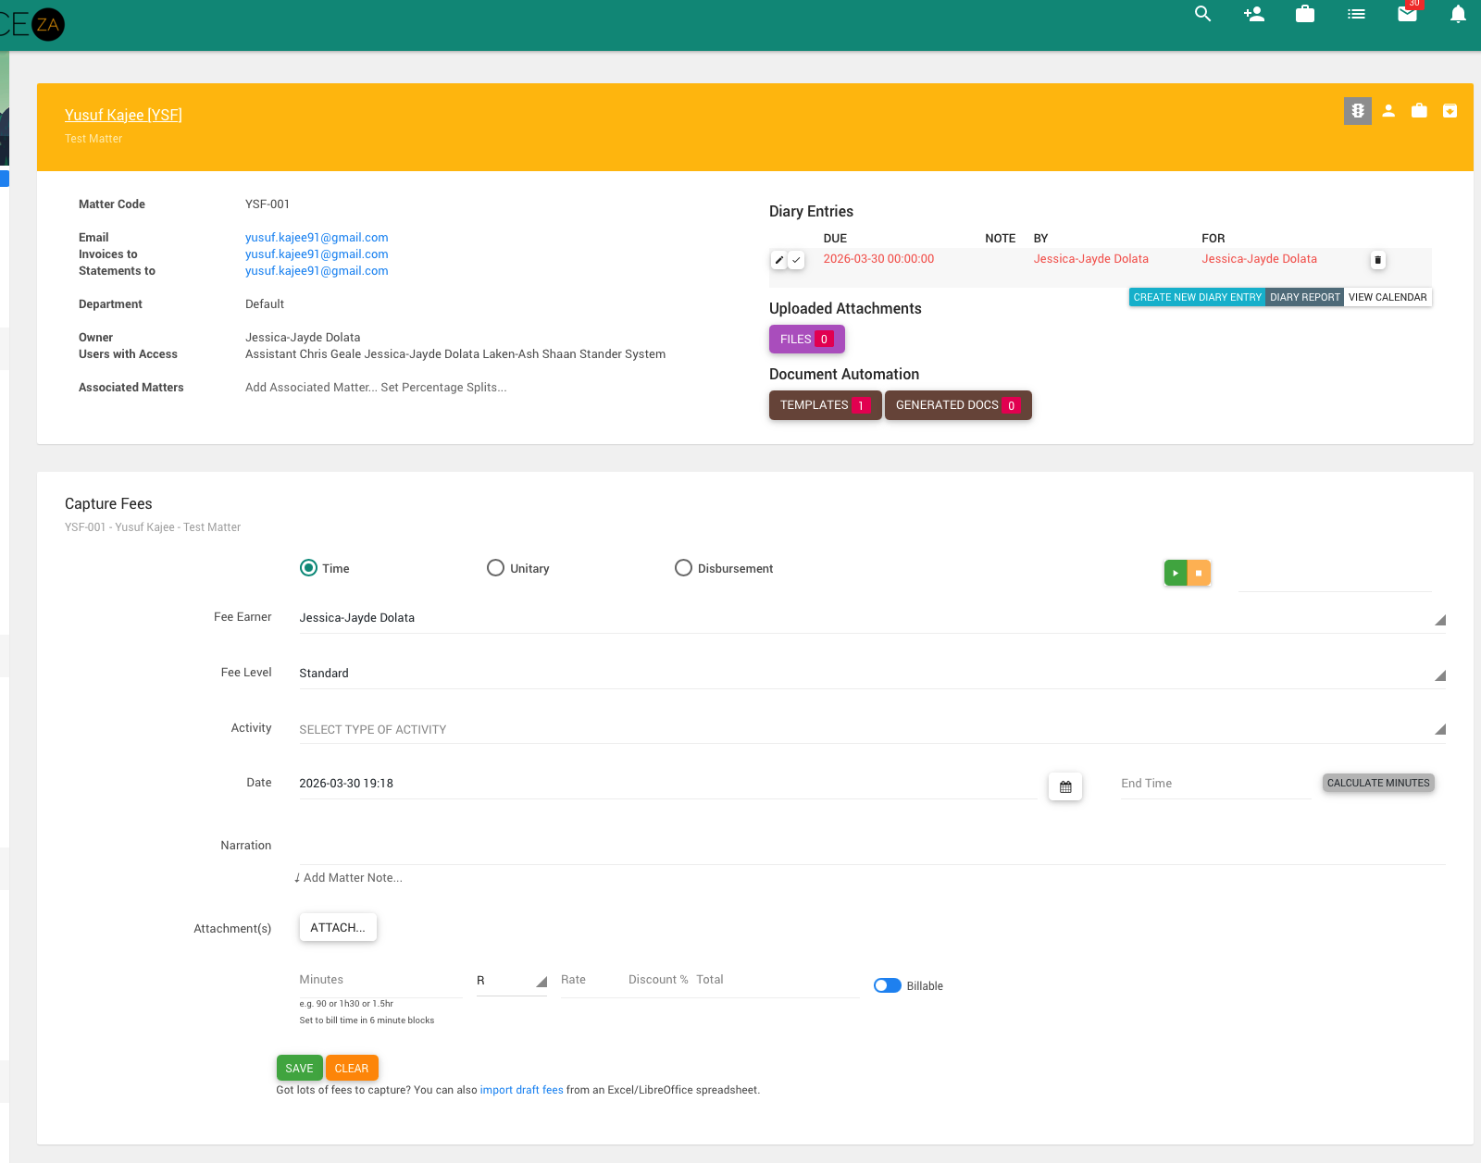

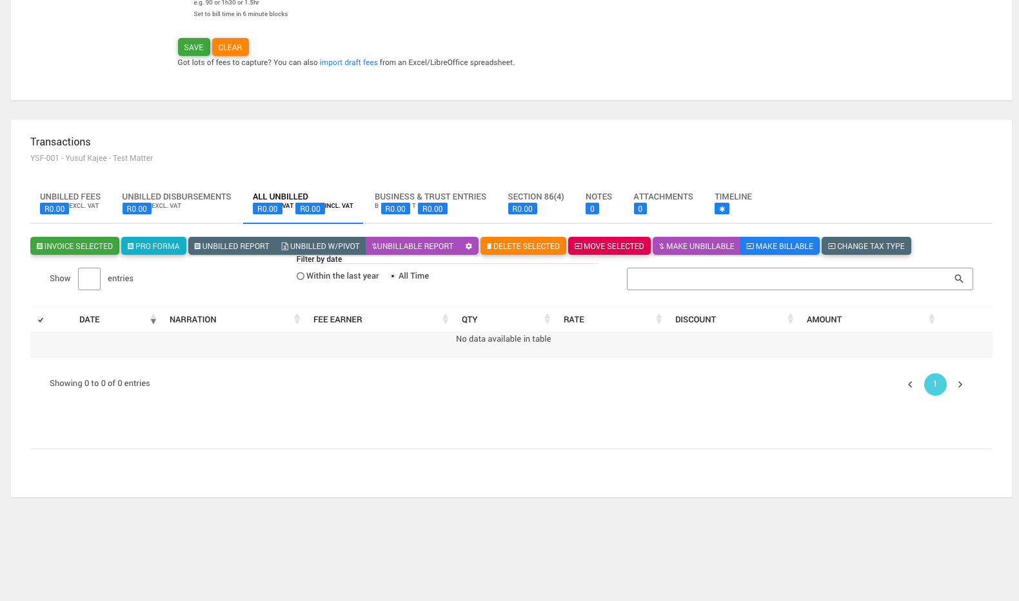

Changes:

Want it to be user friendly and easy to see what needs to be done (from the diary and to do etc)

Place to input fees is good but must be able to go into the matter and see what we have done and what is to do.

Can this link to emails by way of a reference number? Ie. If we always put a reference in our emails can it come here?

Clients
What it looks like on Law Practice (Shit):

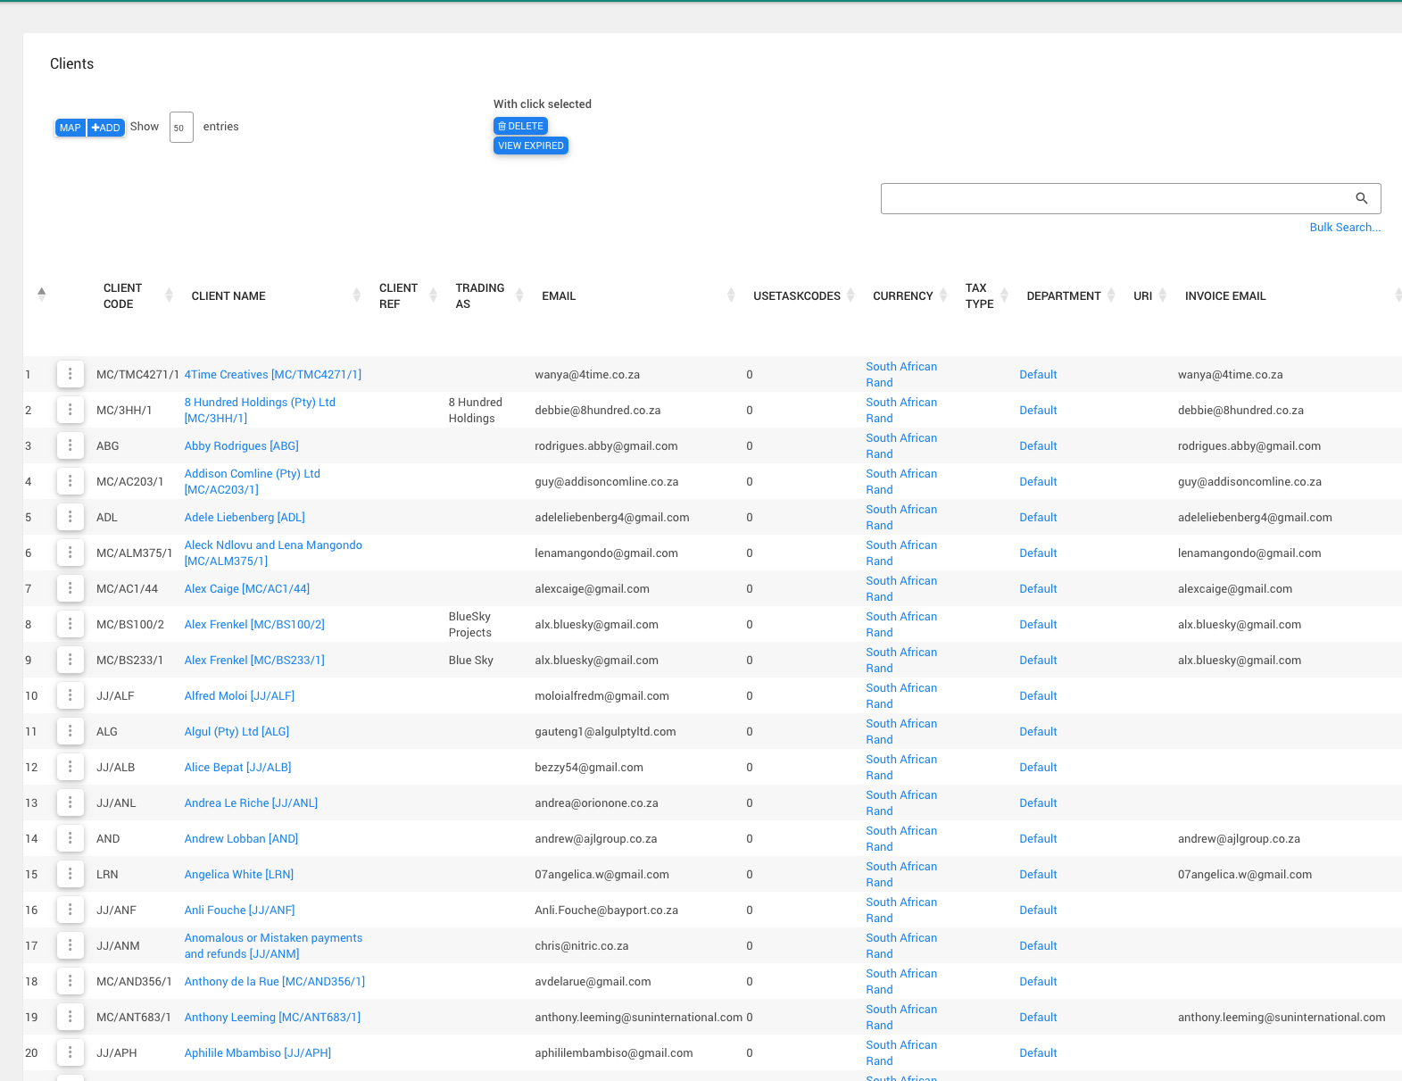

Almost like a phone book with the client’s – what I want it to have

Client Surname, First name* | Client Code | Client email | Client phone | FICA Status | Links to matters

* Always can change between surname or first name first.

Then if you click the client more information becomes available:

IE:
- List of all their matters
- Link to statements / billing
- Amounts outstanding
- Contact details

Contact details:

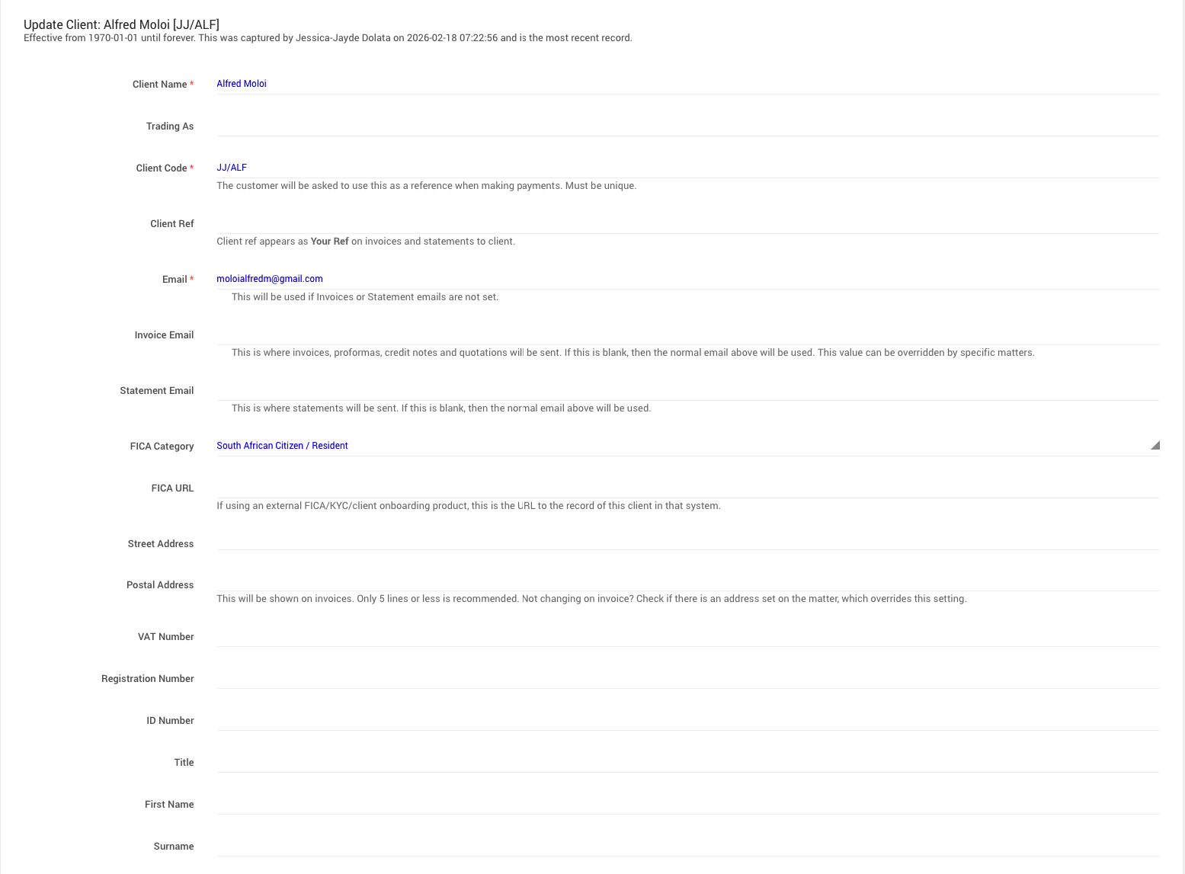
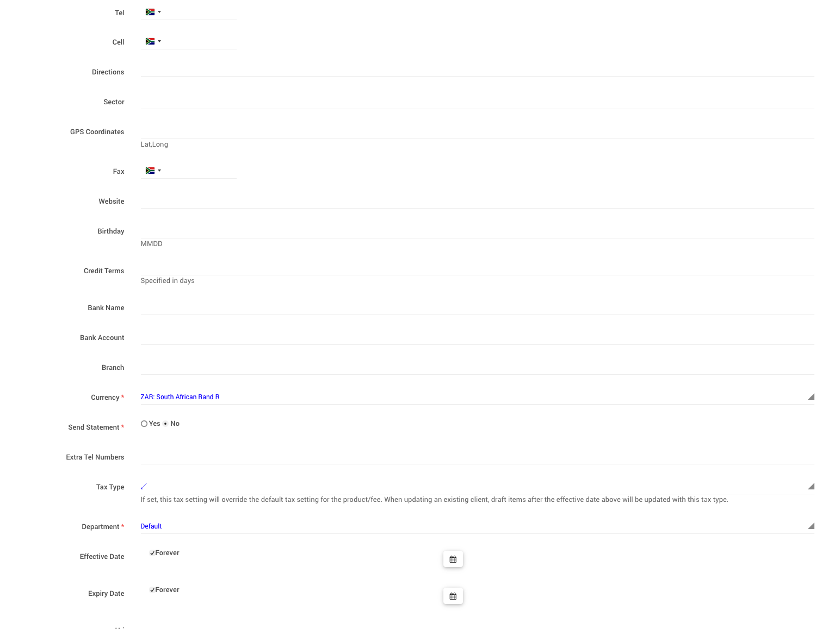
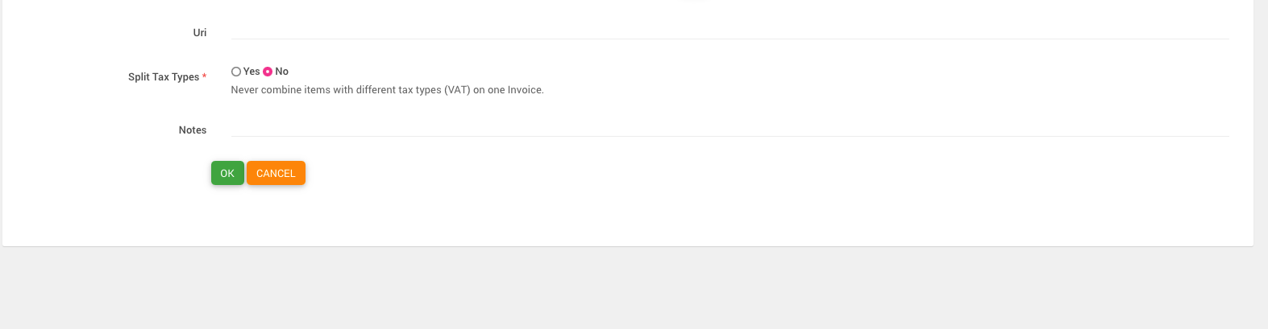

New Client Leads
(new pop up page / link)

This is where I keep a database of all clients that enquire. Looks like this right now:

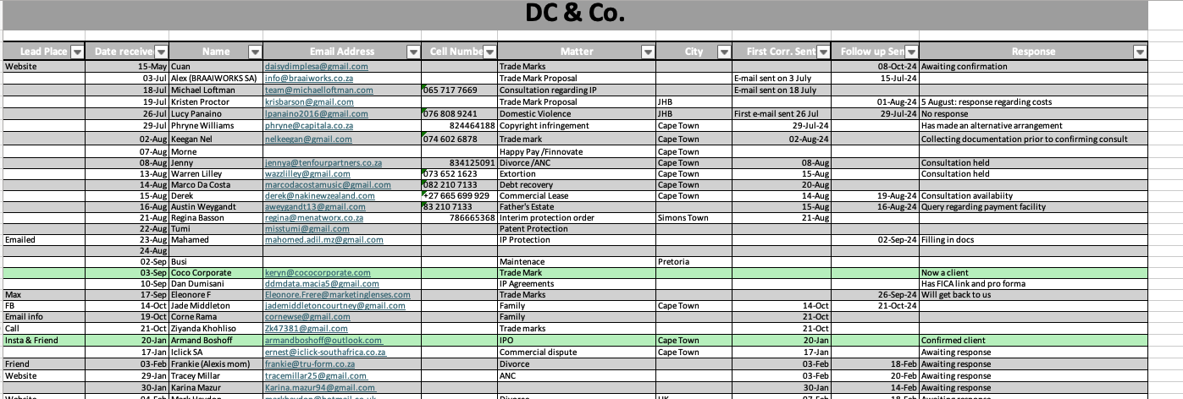

My time sheet – moves to BILLING

Diary

For same use as apple calendar – must have integration with email addresses.

Make it look similar to apple calendar cause we all love that. Same features.

DEADLINES NB.

Notifications of calendar entries. Must integrate with matters.

Practice Overview
? not sure if need but I guess it shows additional things so if I have check ins with my staff I can see everything (combines matters and clients & billing) –

Client Surname, FN | Matter Subject | Summary | To Do + Allocation* | Status | Comment/ Deadline | Last Bill Sent | Monies owed | FICA / LOE

Notes:
- If client’s owe money then their line item goes red.

Currently looks like this:

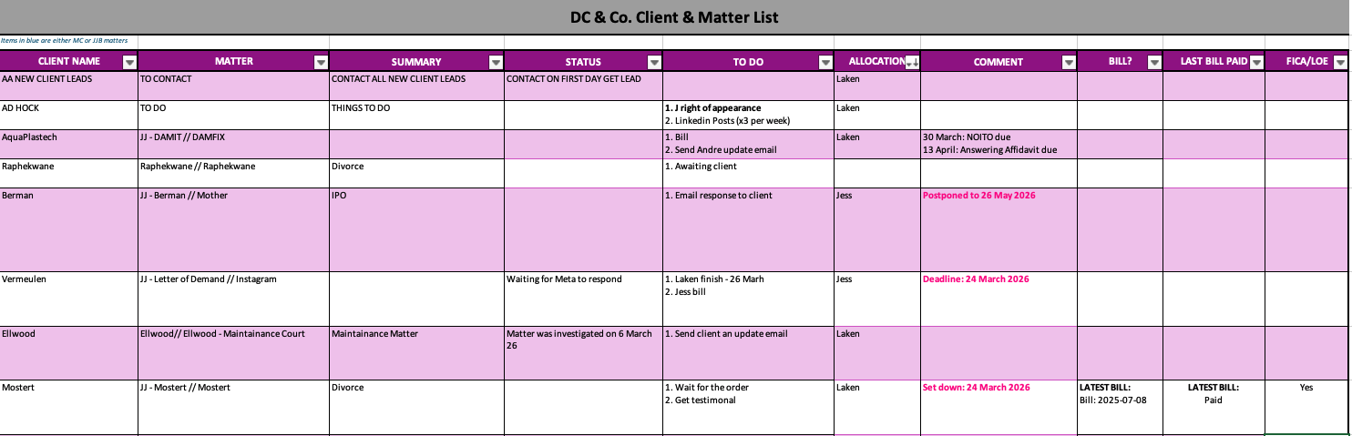

BILLING

My Time Sheet
Goes here

This can have an overview of the month / last month / Target again at the top.Include graph as per the dashboard.

Purpose:
- For quick inputting of fees.
- Seeing what have timed
- Display matters which have fees for this day/ month / week so you can quickly select a matter and add fees (toggle between week and month – so when you toggle you see what you have already inputted for the month / week) so you can quickly add things.

Perhaps have a side panel of a diary entry for the day so you can include what you did throughout the day.

Current law practice set up (horrible): - make this a side panel

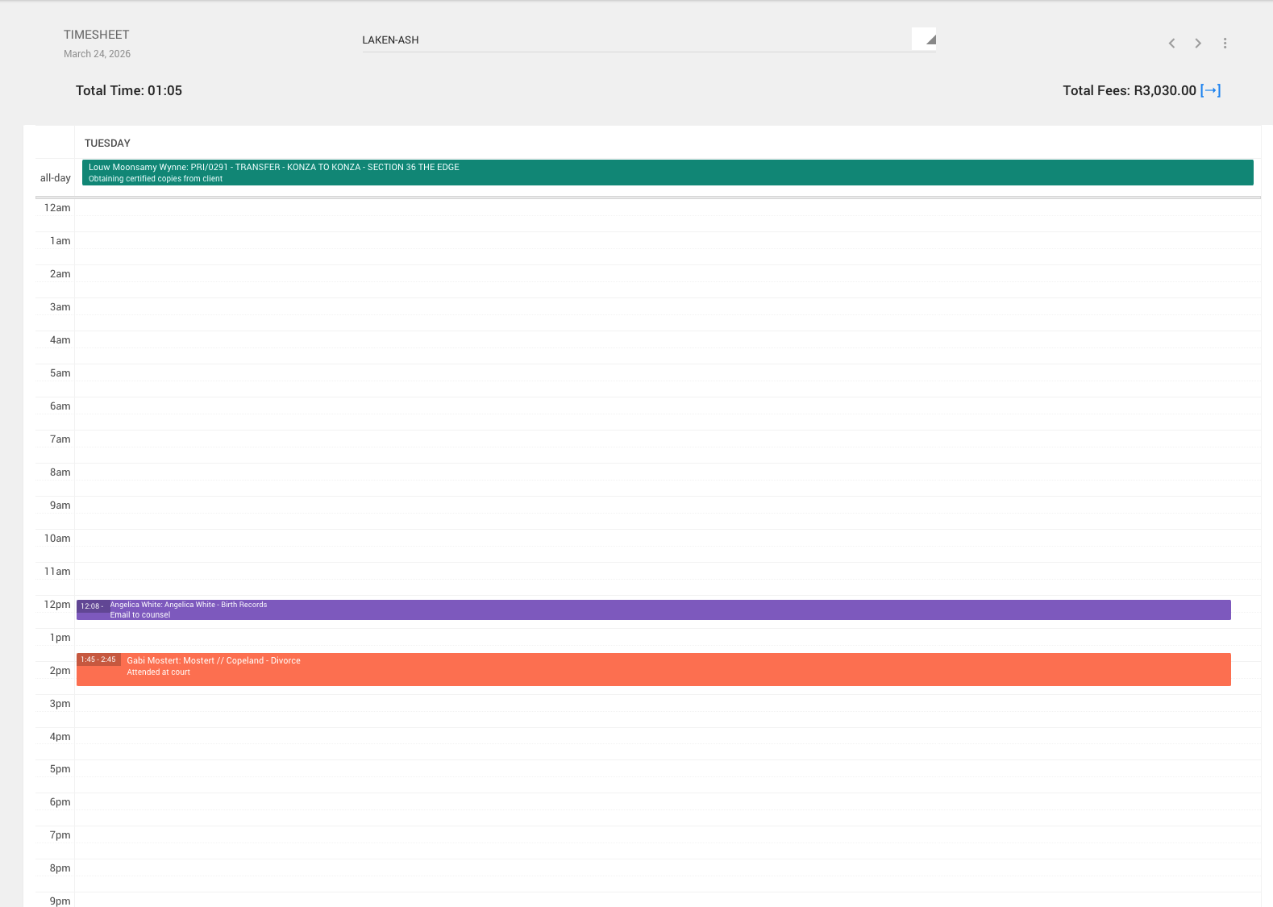

Unbilled Fees

(Changed from Invoicing)

This must reflect a list of all the unbilled fees and disbursments already recorded.

Law practice looks like this:
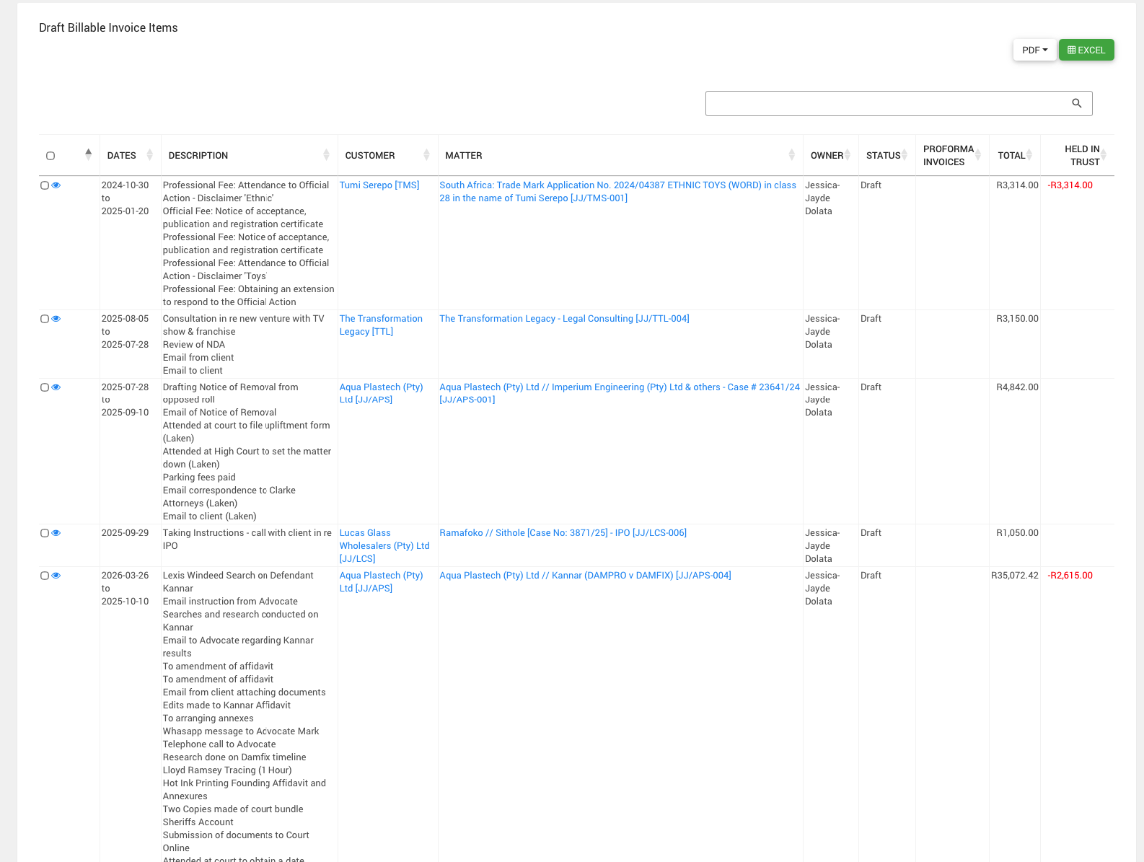

You can click on them and edit them.

*must be able to create pro forma invoices

Debtors

List of all client’s that owe money and what invoices categorized.

Fee Schedules

Ok this is a place to input fees and rates.

Must be categorized:

General Fees
- Hourly rates
- Fixed Fees
- Disbursement Fees

Trade Marks
- South Africa
- Australia
- United Kingdom
- America

(Should be able to add more as we go along and then these must link to when inputting fees in the time sheet and when in the specific matters)

ACCOUNTS

Trust Account

Purpose:

- Place to input trust entries
- See which clients still have trust funds
- Have trust transactions
- Insert trust bank statements

Law prac looks like this:

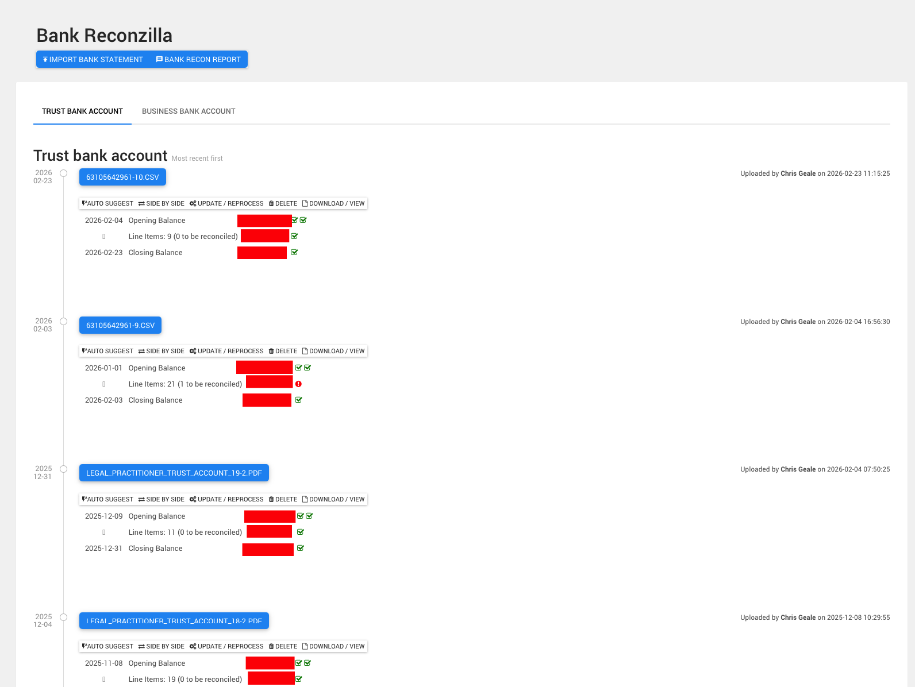

Business Account:

- Place to put business transactions
- See how much is in business
- Add received invoices so that I know to pay them from the business account – this must then go in the diary

Law Prac has this:

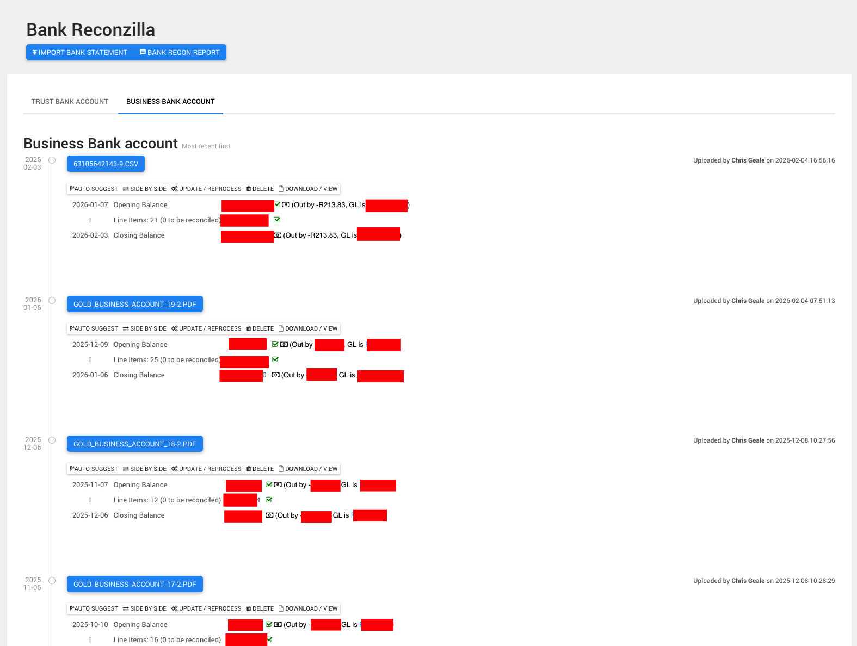

Bank Recon

Lol ok currently confused as to how the recon works with this.

Collections

?? Confused – is this not the same as debtors? Or no this says how long its been outstanding

So then we must be able to add a column to say what we have done ie:

Invoice sent on x date
Followed up on x date
Letter of demand
Warned of summons
Summons

Etc

Also a way to calculate interest on the outstanding accounts per our letter of engament

COMPLIANCE

Letters of Engament
(ADD)

Place for us to send letters of enagement to clients – link to adobe sign?

List of clients to see if they have signed and so we can quickly also access what fees we gave them as per the LOE

FICA

This is also document vault for clients to upload their FICA docs.

As it is we ask clients to visit a link.

Here is an example for you:

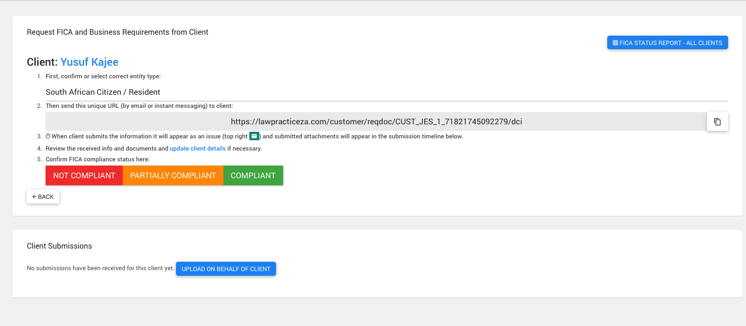

https://lawpracticeza.com/customer/reqdoc/CUST_JES_1_71821745092279/dci

(you select what you are and it generates different document requests)

Reports

Ok here I just want to be able to access things quiuckly for things like my Audit / Tax season.

I don’t understand this stuff so we can get to it lol

